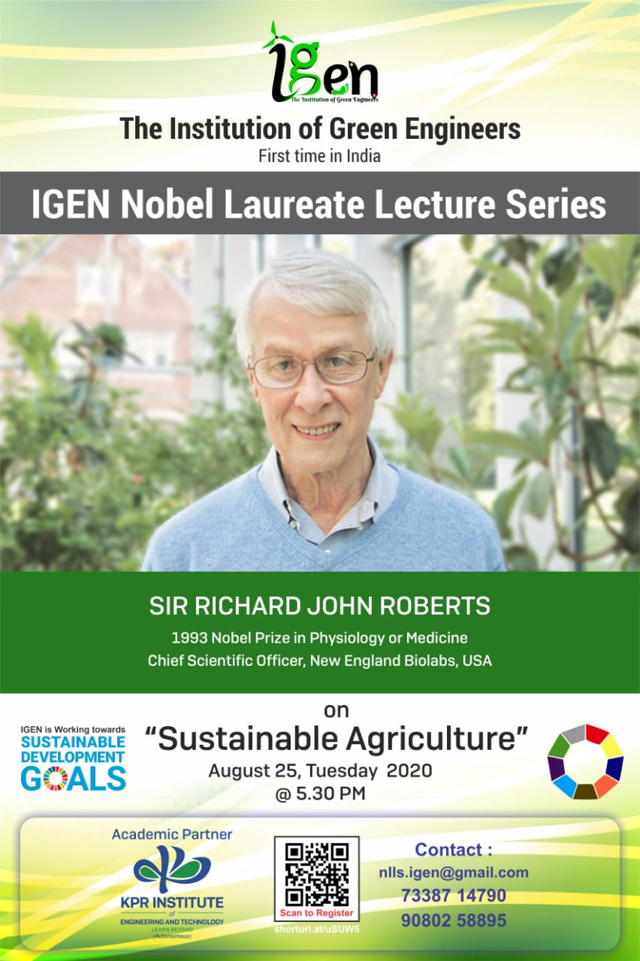

**An Awe-Inspiring International Multifold Competition about Nobel Laureate (your thoughts Your Creativity)**

***“SNAP AND SHARE”***

***-Selfie with sustainable***

**RULES:**

* *Upload a selfie with your home plant and share two ideas for* ***sustainable agriculture towards 2050.***
* *Eligiblity criteria - General public – Retired person/ House wife*

**AWARDS:**

* A medal and a certificate holding the ***Signature*** of ***Nobel Laureate Sir Richard John Roberts*** will be given to ***best 3 entries***.
* ***Winning entries*** will be ***showcased*** during the ***live streaming*** of the event and also published on “IGEN Nobel Laureate Lecture Series” website.

For more information on the above, contact,

DR. BALAJI (73387 14790)

MR. GOKUL S.N.T (96292 50773)